Install Jenkins and Creation of new job

**Pre-requisites:**

**Software requirements: Need either Java Development Kit (JDK) or Java Runtime Environment (JRE).**

Problem Statement: To understand how to install Jenkins and creation of new job.

**Steps to execute:**

1. Jenkins can be downloaded from<https://jenkins.io/download/>

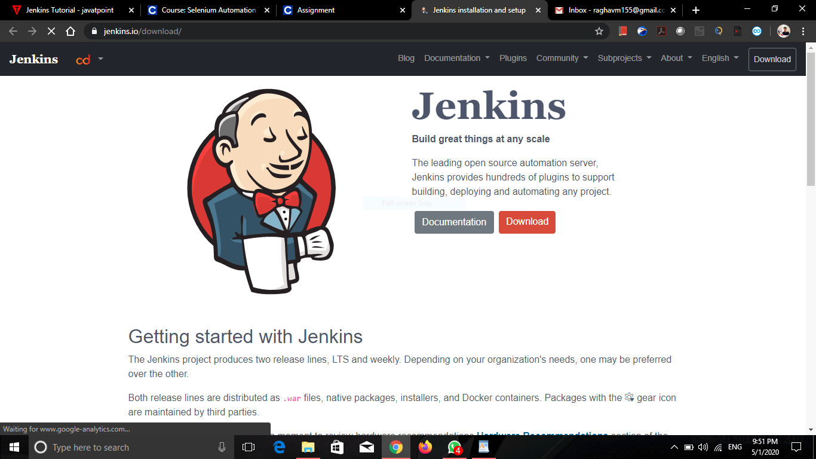

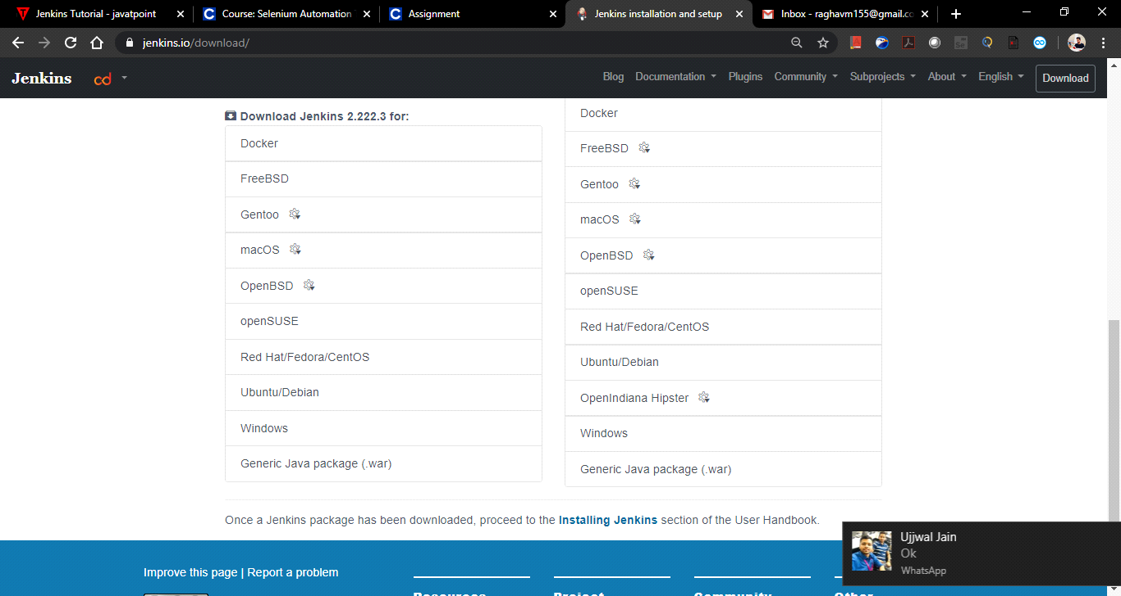

1. After install, configure Jenkins, by launching the Jenkins URL <http://localhost:8080>. If the URL launched, which means the Jenkins is successfully installed. Provide the admin password, from the Jenkins installation path. Normally it will be under …/Jenkins/secrets folder.

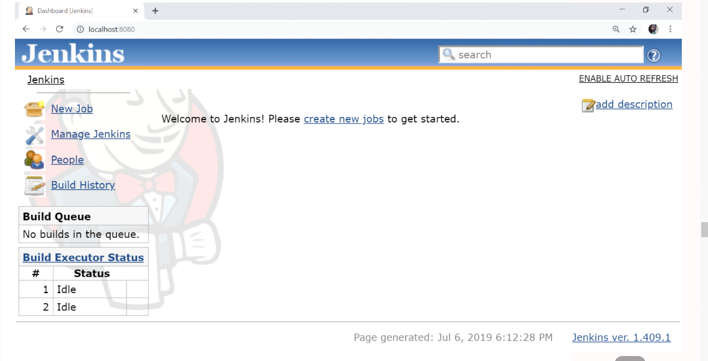

1. Install plugins needed to create new Jenkin jobs. After successful installation of plugins, create a new account or continue as admin and provide the Jenkins URL and click ‘Save and Finish’.

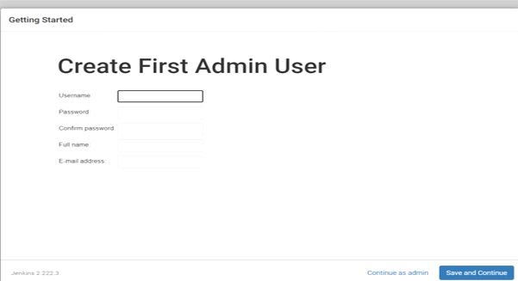

1. Create a new job and do configurations by providing project name, description, Source code management, build Trigger, build options etc. and required post-Build options configurations after job execution.

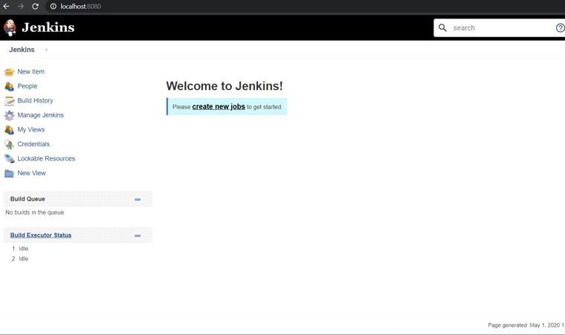

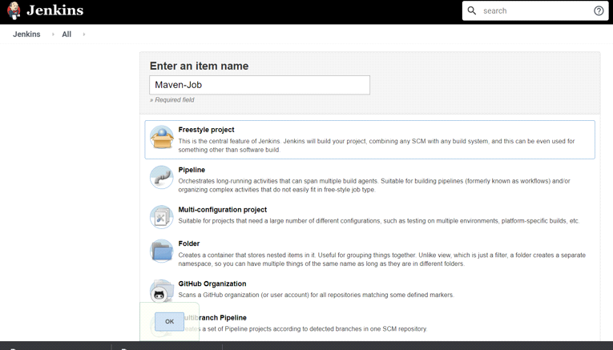

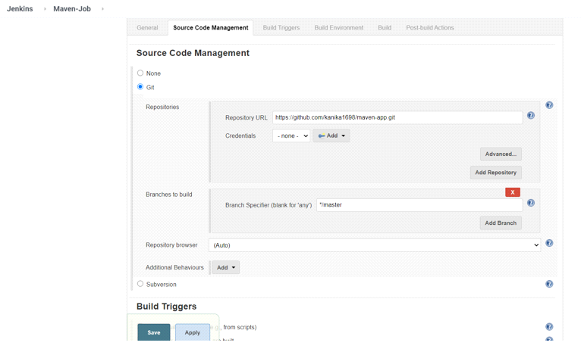

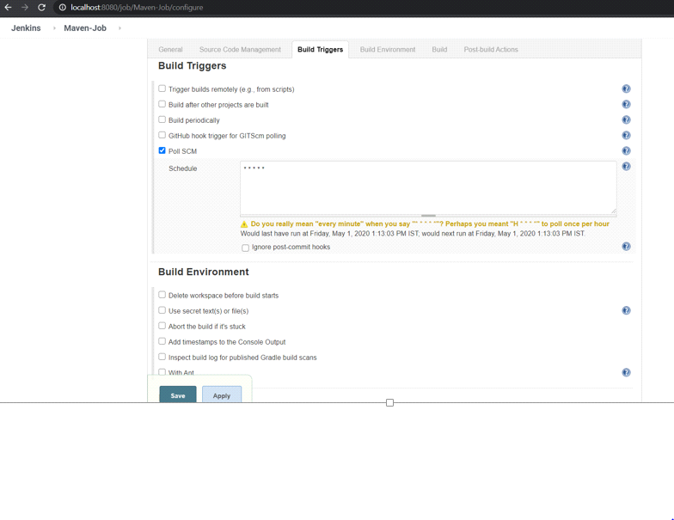

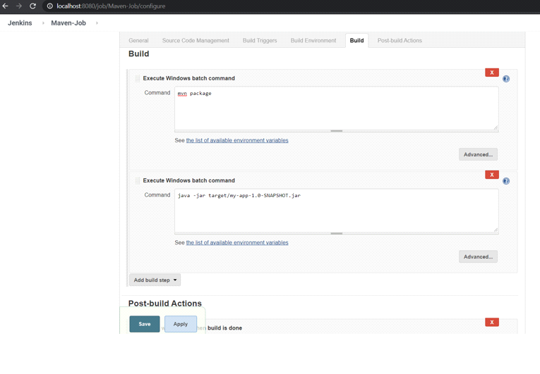

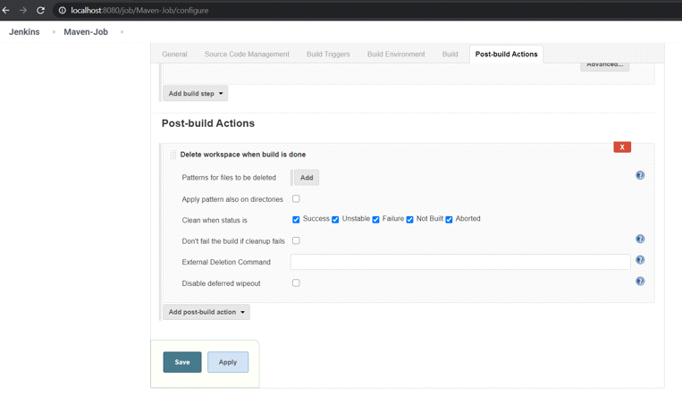

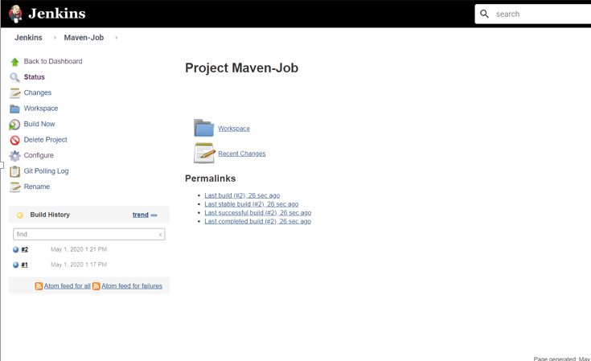

1. Take screenshot of run results in the Jenkins dashboard.

